**SAGE UNIVERSITY**

Powered by Sunstone Education Private Limited

**Academic Session- Jan-June- 2025**



A report on

**“Amazon Prime Clone”**

Submitted in the partial of the requirement for the degree of the Bachelor of Computer Application

**Guided by: Submitted by:** Jiya Jain

Prof. Sneha Singh

**Enroll No. :**

23COA2BCA1041

**Table of Content-**

1. **Abstract**  
    1.1 Problem Statement  
    1.2 Proposed Solution
2. **Introduction**  
    2.1 Need for the Project  
    2.2 Objectives  
    2.3 Domain Description (Entertainment & Streaming Platform)
3. **Technology Used / Tools Used / Programming Languages Used**  
    3.1 HTML – Structure of Web Pages  
    3.2 CSS – Styling and Layout  
    3.3 JavaScript – Interactive Features and Page Logic  
    3.4 Tools – Code Editor (e.g., VS Code), GitHub

**4. Algorithm or Flow Chart**  4.1 User Flow Chart (Sign Up → Sign In → Home → Redirect to Amazon)  
  4.2 Page Navigation Logic

1. **Code**  
    5.1 Sign-Up and Sign-In Page Code  
    5.2 Home Page Code with Redirect Script  
    5.3 Styling with CSS  
    5.4 Basic JavaScript Form Validation
2. **Output**

Interface of the website

1. **Future Scope of the Project**  
    6.1 Add Video Streaming Capability  
    6.2 Backend Integration with Database  
    6.3 Personal User Dashboard and Watch History
2. **Limitations of the Project** 7.1 No Actual Streaming Functionality  
    7.2 No Backend or User Authentication System  
    7.3 Only Front-End Functionality

**9. References**  
  8.1 Amazon Prime Video UI/UX  
  8.2 GitHub Repositories and Code Snippets  
  8.3 HTML/CSS/JS Documentation

# Abstract

This project is a simplified clone of the Amazon Prime Video platform, developed using HTML, CSS, and JavaScript. It includes a Sign-Up page, Sign-In page, and a Home page that redirects users to the official Amazon website. The goal is to simulate the basic structure and flow of a streaming service using front-end technologies.

# Introduction

With the increasing demand for video streaming platforms, creating a clone of Amazon Prime Video helps in understanding the structure, design, and basic functionality of such platforms. This project lies in the web development domain and focuses on front-end implementation.

# Need for the Project

The project serves as a learning tool for beginners in web development, offering practical experience in building a user interface similar to a real-world streaming application.

# Objectives

To replicate the user interface of Amazon Prime Video using front-end technologies and understand user navigation flow.

# Domain Description

This project belongs to the web development and entertainment domain, simulating a basic streaming platform.

# 3. Technology Used / Tools Used / Programming Languages Used

# 3.1 HTML

Used to structure the content of the web pages.

# 3.2 CSS

Used for styling and layout design of the pages.

# 3.3 JavaScript

Adds interactivity and page logic, like redirecting to the Amazon site.

# 3.4 Tools

Visual Studio Code, GitHub (for resources and collaboration).

# 4. Algorithm or Flow Chart

# 4.1 User Flow

User navigates: Sign-Up → Sign-In → Home → Redirect to Amazon.

# 4.2 Navigation Logic

JavaScript handles navigation and form validation.

# 5. Code

# 5.1 Sign-Up and sign-in Page Code

|  |
| --- |
| <!DOCTYPE html>  <html lang="en">  <head>      <meta charset="UTF-8">      <meta http-equiv="X-UA-Compatible" content="IE=edge">      <meta name="viewport" content="width=device-width, initial-scale=1.0">      <title>Signin form</title>      <link rel="stylesheet" href="signin.css">  </head>  <body>      <div  class="main">          <div class="image">              <center><img src="./img/logo 2.png" alt="logo" ></center>          </div>          <div class="box">              <h1>Sign in</h1>              <label for="email/number">Email or mobile phone number</label>              <input type="text" id="Email" name="Email">              <br>              <label for="password">password  <span>                  &nbsp;&nbsp;&nbsp;&nbsp;&nbsp;&nbsp;&nbsp;&nbsp;&nbsp;&nbsp;&nbsp;&nbsp;&nbsp;&nbsp;&nbsp;&nbsp;&nbsp;&nbsp;&nbsp;&nbsp;&nbsp;&nbsp;&nbsp;&nbsp;&nbsp;&nbsp;                  <a href="" class="id">Forgot your password?</a>              </span>             </label>              <input type="password" id="password" name="password">              <br>              <button>Sign in</button>                <p>By continuing, you agree to the Amazon <span><a href="https://www.primevideo.com/help/ref=av_auth_te?nodeId=202064890">Conditions of Use and Privacy Notice.</a></span></p>               <p> &#9744;    Keep me signed in. Details  &#9662; </p>                <div class="breck">                  <center><p>New to amazon?</p></center>              </div>                <div class="Btn">              <a href="https://www.amazon.in/ap/register?showRememberMe=true&openid.pape.max_auth_age=0&openid.identity=http%3A%2F%2Fspecs.openid.net%2Fauth%2F2.0%2Fidentifier_select&accountStatusPolicy=P1&siteState=262-0788730-0988518&language=en_US&pageId=amzn_prime_video_ww&mobileBrowserWeblabTreatment=C&openid.return_to=https%3A%2F%2Feu.primevideo.com%2Fauth%2Freturn%2Fref%3Dav_auth_ap%3F_t%3DsgytyrgoDeS8GODCmX6jY43JF7MR0KHJmMIzD7N4dNOJPAAAAAQAAAABjxP_tcmF3AAAAAPgWC9WfHH8iB-olH_E9xQ%26location%3D%2F%3Fgclid%253DCjwKCAiA5Y6eBhAbEiwA_2ZWIUzJ1rVj8vX5E1O6n61QhUdB088bvhxeCHReAj6SHJSaJBheJrF0aRoCZ-gQAvD_BwE%2526ref_%253Datv_auth_pre%2526mrntrk%253Dpcrid_610141119780_slid__pgrid_84577172368_pgeo_1007740_x__adext__ptid_kwd-821391705347&prevRID=5HXYE6W8M7CZP2FR4WRY&openid.assoc_handle=amzn_prime_video_sso_in&openid.mode=checkid_setup&desktopBrowserWeblabTreatment=C&prepopulatedLoginId=&failedSignInCount=0&openid.claimed_id=http%3A%2F%2Fspecs.openid.net%2Fauth%2F2.0%2Fidentifier_select&openid.ns=http%3A%2F%2Fspecs.openid.net%2Fauth%2F2.0">                  <button >Create your amazon account</button>              </a>             </div>          </div>      </div>     <center> <footer class="links">      <a href="https://www.primevideo.com/help/ref=av_auth_ter?nodeId=202064890"> Terms and Privacy Notice </a>&nbsp;&nbsp;      <a href="https://www.amazon.in/ap/signin?openid.pape.max_auth_age=0&openid.return_to=https%3A%2F%2Feu.primevideo.com%2Fauth%2Freturn%2Fref%3Dav_auth_ap%3F_t%3Dsg-LTSuvRQH0BCgOne6DR-_s9kyg4TQQuxGXHnZrGstzpAAAAAQAAAABjxPlWcmF3AAAAAPgWC9WfHH8iB-olH_E9xQ%26location%3D%2Fhelp%2Fcontact-us%3Fref_%253Datv_auth_red_aft&openid.identity=http%3A%2F%2Fspecs.openid.net%2Fauth%2F2.0%2Fidentifier_select&accountStatusPolicy=P1&openid.assoc_handle=amzn_prime_video_sso_in&openid.mode=checkid_setup&siteState=262-0788730-0988518&language=en_US&openid.claimed_id=http%3A%2F%2Fspecs.openid.net%2Fauth%2F2.0%2Fidentifier_select&openid.ns=http%3A%2F%2Fspecs.openid.net%2Fauth%2F2.0">          Send us feedback </a>&nbsp;&nbsp;      <a href=""> Help </a>      <p>© 1996-2023, Amazon.com, Inc. or its affiliates</p>      </footer></center>    </body>  </html> |

# 5.2 Home Page Code - index.html

|  |
| --- |
| <!DOCTYPE html>  <html lang="en">  <head>      <meta charset="UTF-8">      <meta http-equiv="X-UA-Compatible" content="IE=edge">      <meta name="viewport" content="width=device-width, initial-scale=1.0">      <title>Welcome to prime video</title>      <link rel="shortcut icon" href="./img/nav-icon.png" type="image/png">      <link rel="stylesheet" href="style.css">      <script src="https://kit.fontawesome.com/ccf39ecc94.js" crossorigin="anonymous"></script>  </head>  <body>    <nav>      <div class="logo">          <img src="./img/logo.png" alt="logo">          <div class="menu-left">            <a href="#">Home</a>            <a href="https://www.primevideo.com/storefront/ref=atv_hm_pri_c_9zZ8D2_1_2?merchId=RentBuy&ie=UTF8">Store</a>            <a href="https://www.primevideo.com/storefront/channels/ref=atv_hm_pri_c_9zZ8D2_1_3">Channel</a>            <a href="#">Categories             <i class="fas fa-caret-down arrow-down lang-btn"></i>           </a>            <a href="signin-form.html">My Stuff</a>          </div>       </div>           <div class="menu-right">          <a href="signin-form.html">            <button class="Btn" type="button">Try for free</button> </a>          <a href="#"> <i class="fas fa-search"></i></a>          <a  class="dropdown-Btn" >            <i class="fas fa-globe"></i>            EN               <i class="fas fa-caret-down arrow-down lang-btn"  >               </i>               <div id="languages" class="Ldd">                <li><a href="">Bahas indonesia</a></li>                <li><a href="">Bahas melayu</a></li>                <li><a href="">Dansk</a></li>                <li><a href="">Deutsch</a></li>                <li><a href="">English</a></li>                <li><a href="">Espanol</a></li>                <li><a href="">Francais</a></li>                <li><a href="">Italiano</a></li>                <li><a href="">Magyar</a></li>                <li><a href="">Nedarlands</a></li>                <li><a href="">Norsk</a></li>                    <div class="Ld1">                      <li><a href="">Polski</a></li>                      <li><a href="">Português (Brasil)</a></li>                      <li><a href="">Português (Portugal)</a></li>                      <li><a href="">Română</a></li>                      <li><a href="">Suomi</a></li>                      <li><a href="">Svenska</a></li>                      <li><a href="">Türkçe</a></li>                      <li><a href="">Wikang Filipino</a></li>                      <li><a href="">Čeština</a></li>                      <li><a href="">Ελληνικά</a></li>                      <li><a href="">PyCCkNN</a></li>                    </div>                    <div class="Ld2">                      <li><a href="">עברית</a></li>                      <li><a href="">العربية</a></li>                      <li><a href="">हिन्दी</a></li>                      <li><a href="">தமிழ்</a></li>                      <li><a href="">తెలుగు</a></li>                      <li><a href="">日本語</a></li>                      <li><a href="">简体中文</a></li>                      <li><a href="">繁體中文</a></li>                      <li><a href="">한국어</a></li>                    </div>               </div>            </a>              <a class="dropdown_button"                   onclick="show_list()">            <i class="fas fa-user-alt"></i>              <i class="  fas fa-caret-down arrow-down lang-btn "> </i>              <div id="courses_id" class="courses">                <li><a href="signin-form.html">Sign in</a></li>                <li><a href="https://www.primevideo.com/splash/watchAnywhere/ref=atv_nb_wa">Watch AnyWhere</a></li>                <li><a href="https://www.primevideo.com/help/ref=atv_nb_hp">Help</a></li>            </div>            </a>            </div>    </nav>     <header >      <img src="./img/home-1.jpg" alt="poster">       <div class="text-over-img">          <h1>Welcome to Prime Video</h1>          <p>Watch the latest movies, TV shows, and award-winning Amazon <br>              Originals</p>             <a href="signin-form.html">              <button type="button">                Sign in to join Prime</button>             </a>         </div>     </header>     <header >      <img src="./img/home-2.jpg" alt="poster">      <div class="text-over-img-1">          <h1>Movie rentals on Prime Video</h1>          <p>Early Access to new movies, before digital subscription</p>          <br>          <br>             <a href="https://www.primevideo.com/storefront/ref=atv_hm_hom_c_9zZ8D2_1_2?ie=UTF8&merchId=RentBuy">              <button type="button">Rent now</button>             </a>      </div>     </header>     <section >       <div id="section">         <div class="text-area">          <h1>Your favorite channels all in one<br> place</h1>          <p>With Prime Video Channels, find shows and movies from your<br> favorite channels all in one place. Enjoy with an add-on <br>subscription to Channels of your choice          </p>         </div>         <div class="channelBtn">         <a href="https://www.primevideo.com/gp/video/offers?benefitId=lionsgateplayin"> <img src="./img/channels/LionsgatePlay.jpg" alt="img"></a>          <a href="https://www.primevideo.com/gp/video/offers?benefitId=discoveryplusin"><img src="./img/channels/Discovery.jpg" alt="img"></a>          <a href="https://www.primevideo.com/gp/video/offers?benefitId=erosnowin"><img src="./img/channels/Erosnow.jpg" alt="img"></a>          <a href="https://www.primevideo.com/gp/video/offers?benefitId=manoramamaxin"><img src="./img/channels/MANORAMAMAX.jpg" alt="img"></a>          <a href="https://www.primevideo.com/gp/video/offers?benefitId=hoichoiin"><img src="./img/channels/hoichoi.jpg" alt="img"></a>          <a href="https://www.primevideo.com/region/eu/ref=dv_web_force_root?contentId=vrottin&benefitId=vrottin&contentType=subscription"><img src="./img/channels/Vrott.png" alt="img"></a>          <a href="https://www.primevideo.com/region/eu/ref=dv_web_force_root?contentId=amcplusin&benefitId=amcplusin&contentType=subscription"> <img src="./img/channels/Amc.png" alt="img"></a>          <a href="https://www.primevideo.com/gp/video/offers?benefitId=docubayin"><img src="./img/channels/Docubay.jpg" alt="img"></a>          <a href="https://www.primevideo.com/gp/video/offers?benefitId=mubiin"> <img src="./img/channels/Mubi.jpg" alt="img"></a>          <a href="https://www.primevideo.com/region/eu/ref=dv_web_force_root?contentId=iwonderin&benefitId=iwonderin&contentType=subscription"> <img src="./img/channels/iWonder.png" alt="img"></a>          <a href="https://www.primevideo.com/region/eu/ref=dv_web_force_root?contentId=hayuin&benefitId=hayuin&contentType=subscription"><img src="./img/channels/Hayu.jpg" alt="img"></a>          <a href="https://www.primevideo.com/region/eu/ref=dv_web_force_root?contentId=stingrayin&benefitId=stingrayin&contentType=subscription"> <img src="./img/channels/Stingray.png" alt="img"></a>       </div>      </div>     </section>       <header class="fire-stick-header">        <img src="./img/home-3.jpg" alt="poster ">       <div class="fire-header" id="firehead">          <h1 class="fire-heading">Even better with Fire TV Stick</h1>          <p class="fire-para">The biggest movies and TV shows are always better on a big screen. <br> Simply plug in your Amazon Fire TV Stick and stream on any HDTV. Press<br> the voice button on the remote and say the name of the title you want to <br>watch to find it in seconds.</p>           <a href="signin-form.html">            <button class="btn" type="button">Get started</button>           </a>      </div>     </header>     <header class="membership-header">      <img src="./img/home-4.jpg" alt="poster ">     <div class="mem-header" id="mem-div">        <h1 class="mem-heading">Family Friendly</h1>        <br>        <br>        <p class="mem-para">With easy to use Parental Controls and a dedicated kids page, enjoy <br>secure, ad-free kids entertainment. Kids can enjoy popular TV shows like <br>Peppa Pig, Powerpuff Girls, and Chhota Bheem.</p>        <a href="signin-form.html">          <button class="btn" type="button">Get started</button>        </a>    </div>   </header>   <footer>    <div id="logo">      <div>          <img src="./img/footer-logo.png" alt="footer-logo" id="footer-img">      </div>      <div id="copy-right">          <p><a href="">Terms and PrivacyNotice</a></p>          <p><a href="">Send us feedback</a></p>          <p><a href="">Help</a></p>          <p class="copy">              © 1996-2022, Amazon.com, Inc. or its affiliates          </p>      </div>    </div>   </footer>         <script src="app.js"> </script>  </body>  </html> |

# 5.3 Home page Styling – style.css

|  |
| --- |
| @import url('https://fonts.cdnfonts.com/css/amazon-ember');  *{      margin: 0;      padding: 0;      box-sizing: border-box;      list-style: none;      outline: none;      font-family: 'Amazon Ember', sans-serif;      text-decoration: none;  }  a{      cursor: pointer;  }  nav{      background-color: #1a242f;      padding: 0px 25px;      display: flex;      justify-content: space-between;      position: sticky;      width: 100%;      z-index: 10;      top: 0;  }  .Btn{      width: 120px;      background-color:#0f79af ;      font-size: 14px;      font-weight: 500;      padding: 8px 5px;      margin-top: 15px;      border: none;      border-radius: 3px;      color: #fff;      cursor: pointer;  }  .logo{      display: flex;  }  .logo img{      width: 180px;      height: 100px ;      object-fit: cover;  }  .menu-left{      padding-top: 45px;      font-size: 18px;      color: rgb(247, 246, 246);    }  .menu-left > a{      padding: 5px 7px;      color: rgb(224, 220, 220);    }  .menu-right{      padding: 25px;      font-size: 22px;      color: #fff;  }  .menu-right a{      padding: 5px 15px;      color: rgb(255, 255, 255);  }  .menu-right.Btn{      color: blue;    }  .menu-right label :hover{      cursor: pointer;  }  .menu-right a:nth-child(2),  .menu > a >label{     font-size: 16px;     padding: 0px 3px;  }  .arrow-down{      font-size: 12px;  }  header{      position: relative;      min-width: 320px;      height: 620px;      overflow: hidden;      color:#fff;  }  header > img{      width: 100%;      object-fit: cover;  }  .text-over-img{      position: absolute;      width: 45%;      height: 100%;      top: 3%;      left: 3%;  }  .text-over-img > h1{      font-size: 50px;      font-weight: 100;      line-height: 70px;      margin-top: 100px;      padding: 20px 0;  }  .text-over-img > p {      font-size: 26px;      line-height: 29px;      font-weight: 100;  }  .text-over-img > a> button {      width: 280px;      background-color:#0f79af ;      font-size: 18px;      font-weight: 500;      padding: 14px 22px;      margin-top: 15px;      border: none;      border-radius: 3px;      color: rgb(255, 255, 255);      cursor: pointer;  }  .text-over-img-1{      position: absolute;      width: 45%;      height: 100%;      top: 7%;      right: -3%;  }  .text-over-img-1> h1{      font-size: 50px;      font-weight: 100;      line-height: 70px;      margin-top: 100px;      padding: 20px 0;  }  .text-over-img-1> p {      font-size: 26px;      line-height: 29px;      font-weight: 100;  }  .text-over-img-1 >a> button{      width: 300px;      background-color:#0f79af ;      font-size: 18px;      font-weight: 500;      padding: 14px 22px;      margin-top: 15px;      border: none;      border-radius: 3px;      color: #fff;      cursor: pointer;  }  #section{  display: flex;  justify-content: space-between;  }  .text-area > h1 {      font-size: 45px;      padding: 40px;      left: 30%;  }  .text-area > p {      font-size: x-large;      padding: 30px;  }  .channelBtn{      width: 40%;      padding-left: 20px;    }  .channelBtn img{      width: 240px;      padding: -2px;    }  .channelBtn img:hover{     cursor: pointer;     box-shadow: 3px 3px 8px #000 , -3px -3px 8px #000;  }  .fire-stick-header{      position: relative;      min-width: 320px;      height: 630px;      overflow: hidden;      color: #fff;  }  .fire-stick-header > img {      width: 100%;      object-fit: cover;  }  .fire-header{      position: absolute;      width: 45%;      height: 100%;      top: 20%;      left: 55%;  }  .fire-header h1{      font-size: 45px;      font-weight: 400;      line-height: 40px;  }  .fire-header p{      font-size: 24px;      font-weight: 300;      line-height: 28px;      width: 800px;      margin: 30px 0;  }  .btn {      width: 280px;      background-color:#0f79af ;      font-size: 18px;      font-weight: 500;      padding: 14px 22px;      margin-top: 15px;      border: none;      border-radius: 3px;      color: #fff;      cursor: pointer;  }  .membership-header{      position: relative;      min-width: 320px;      height: 620px;      overflow: hidden;      color:#fff;  }  .membership-header > img{      width: 100%;      object-fit: cover;  }  .mem-header{      position: absolute;      width: 45%;      height: 100%;      top: 3%;      left: 3%;  }  .mem-header > h1{      font-size: 50px;      font-weight: 100;      line-height: 70px;      margin-top: 100px;      padding: 20px 0;  }  .mem-header > p {      font-size: 26px;      line-height: 29px;      font-weight: 100;  }  #logo{      background-color: #1a242f;      height: 150px;      display: flex;      flex-direction: column;      justify-content: center;      text-align: center;  }  #logo >  div{      text-align: center;      bottom: 5px;  }  #footer-img{      width: 110px;      height: 35px;      object-fit: contain;      text-align: center;  }  #copy-right {      display: flex;      justify-content: center;      margin: 2px 3px;      opacity: 0.7;  }  #copy-right> p{      margin-left: 20px;      padding-bottom: 20px;    }  #copy-right > p > a {   color:#0f79af;   font-size: 15px;  }  .copy{      color: #949494;      text-align: center;      justify-content: center;      position: absolute;      padding-top: 30px;      padding-left: 10px;  }    .dropdown_button {      border: none;      cursor: pointer;      width: 200px;      position: relative;    }  .courses {      display: none;      position:absolute;      right: 2%;      background-color:#1a242f;      box-shadow: 0px 8px 16px 0px rgba(0, 0, 0, 0.2);      z-index: 1;  }  .courses li {      padding: 12px 16px;      text-decoration: none;      display: block;      list-style: none;      background-color:#1a242f;  }  .courses li a {      text-decoration: none;      color: white;      display: block;      padding: 10px;     font-size: 16px;      font-weight: 100;    }  .courses li:hover {      background-color: #9cafbfa3;      color: white;  }  .dropdown-Btn{        border: none;      cursor: pointer;      width: 300px;      position: relative;  }  .Ldd{      display: none;      position:absolute;      background-color:#1a242f;      box-shadow: 0px 8px 16px 0px rgba(0, 0, 0, 0.2);      z-index: 1;  }  .Ldd li {        padding: 12px 16px;      text-decoration: none;      display: block;      list-style: none;      background-color:#1a242f;  }  .Ldd li a {        text-decoration: none;      color: white;      display: block;      padding: 10px;      font-size: 16px;      font-weight: 100;    }  .Ldd li:hover {      background-color: #9cafbfa3;      color: white;  } |

# 5.4 JavaScript Functions – app.js

|  |
| --- |
| function show_list() {      var courses = document.getElementById("courses_id");      if (courses.style.display == "block") {          courses.style.display = "none";      } else {          courses.style.display = "block";      }  }  window.onclick = function (event) {      if (!event.target.matches('.dropdown_button')) {          document.getElementById('courses_id')              .style.display = "none";      }      else {          courses.style.display = "block";      }  } |

# 6.Output

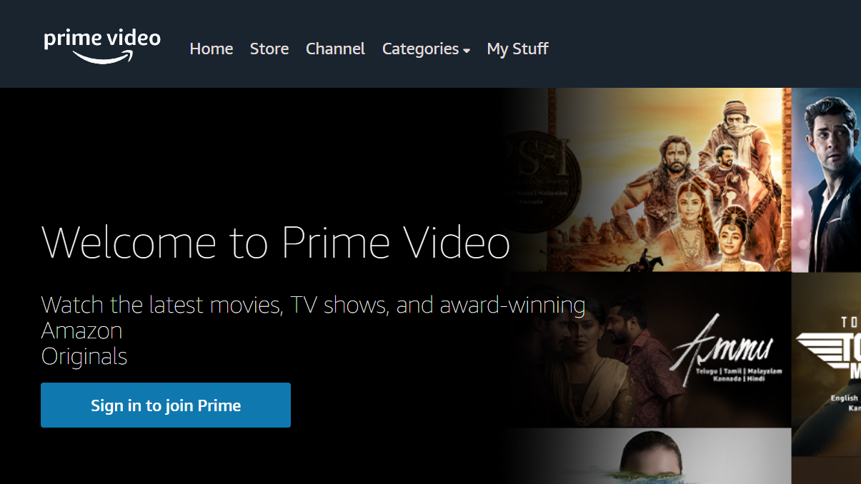

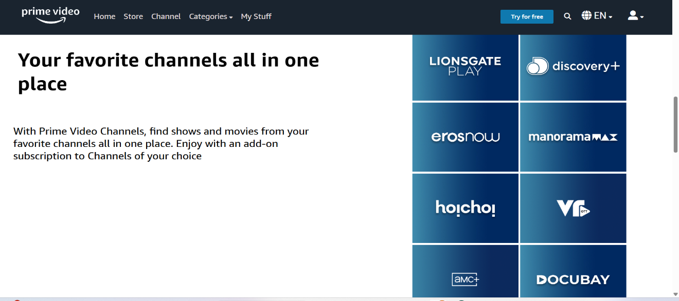

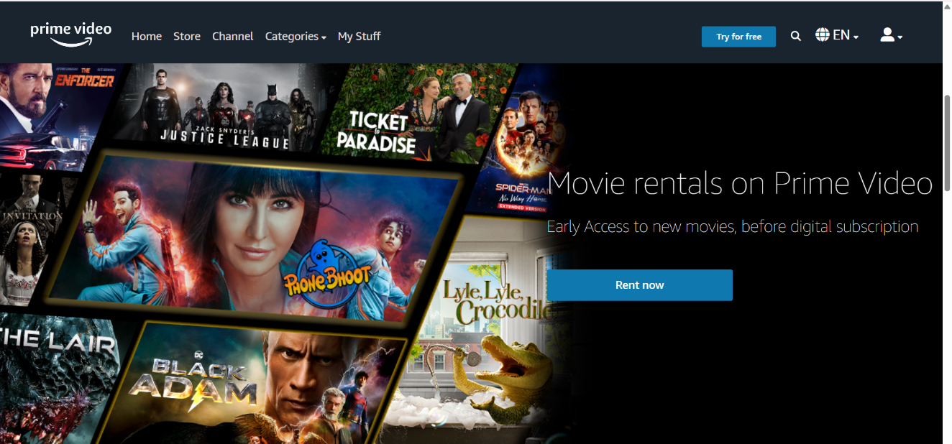

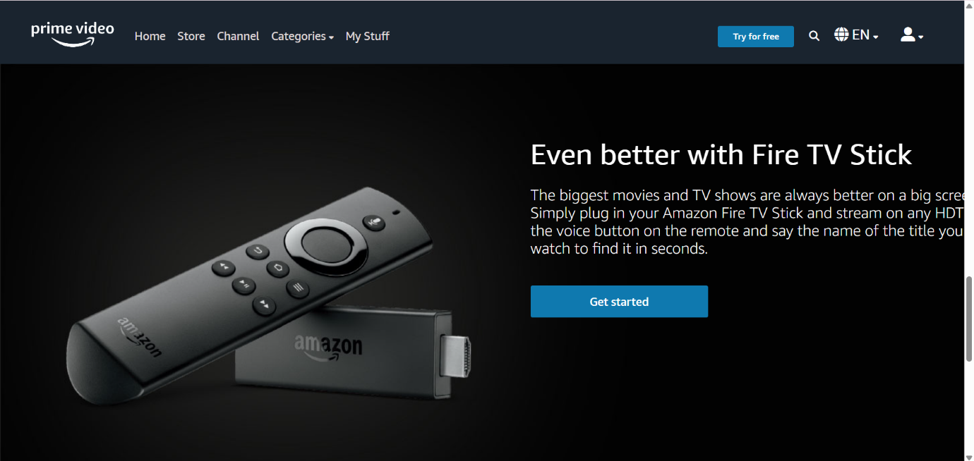

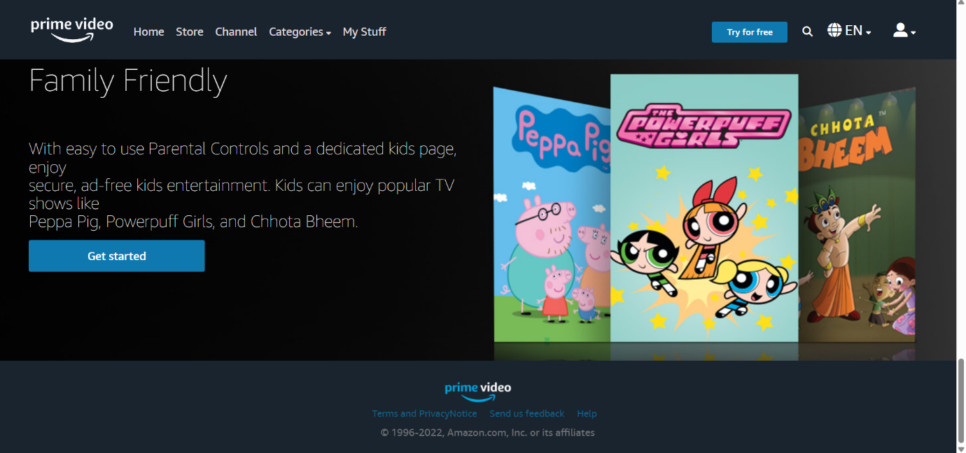

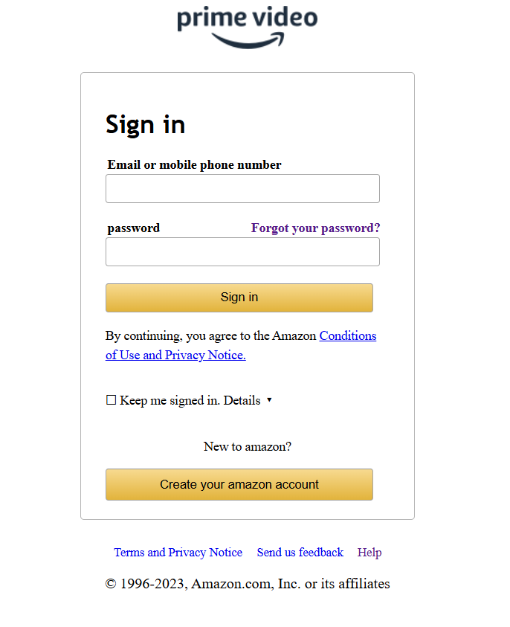

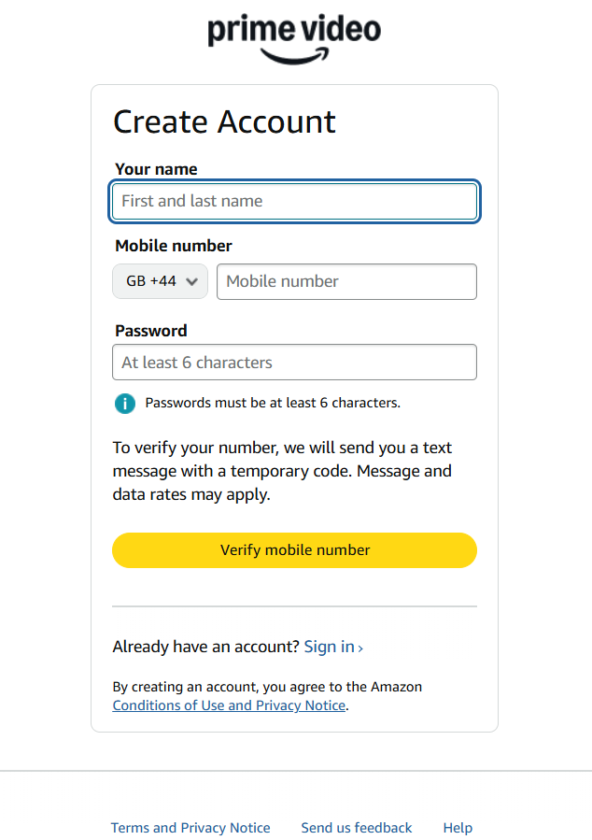

# 7. Future Scope of the Project

• Add real video streaming functionality.  
• Connect to a backend database for storing user credentials.  
• Personalize content for signed-in users.  
• Add admin dashboard and analytics.

# 8. Limitations of the Project

• No backend/database integration.  
• No real authentication mechanism.  
• Only a static front-end simulation.

# 9. References

• Amazon Prime Video interface for design inspiration.  
• GitHub repositories for HTML/CSS/JS samples.  
• W3Schools, MDN Web Docs for HTML/CSS/JS documentation.